The Respiratory System

1. Label the diagram of the respiratory system below.

Trachea, diaphragm, larynx, pharynx, nasal cavity, alveoli, lung, bronchus, ribs, intercostal muscles

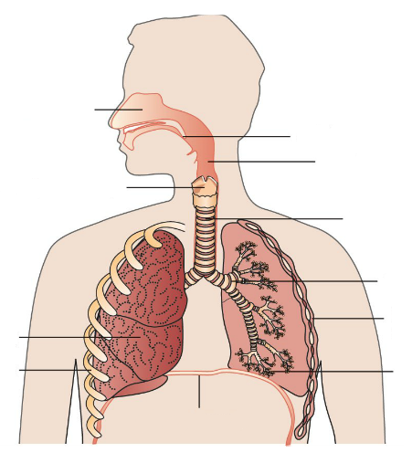

1. Explain the **function** of the following parts of the respiratory system.
   1. Nasal cavity
   2. Trachea (windpipe)
   3. Epiglottis
   4. Ribs
2. Gases are exchanged in the alveoli (singular: alveolus). There are around 500 million alveoli in the lungs, giving a total surface area of about 80 square metres.
   1. Describe the structure of an alveolus.

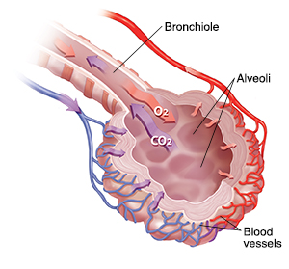

* 1. Explain what happens in an alveolus.

1. The intercostal muscles and diaphragm work together when you inhale and exhale to draw air in and then push it out.
   1. Describe what happens when you **inhale**.
   2. Describe what happens when you **exhale**.

